**COMPUTER VISION FOR OBJECT DETECTION**

**LAB MANUAL**

**Course Code: ITA0530**

**Index:**

|  |  |  |
| --- | --- | --- |
| **S.NO** | **Experiment** | **Page No.** |
| 1 | Gray Scale | 3 |
| 2 | Gaussian Blur | 4 |
| 3 | Canny Function | 5 |
| 4 | Dilate Function | 7 |
| 5 | Erode Function | 8 |
| 6 | Basic Video in Slow and Fast Motion | 9 |
| 7 | Webcam Video in Slow and Fast Motion | 11 |
| 8 | Image – Big to Small Size | 12 |
| 9 | Rotation of Image 90 Degree | 13 |
| 10 | Rotation of Image 180 Degree | 15 |
| 11 | Rotation of Image 270 Degree | 16 |
| 12 | Affine Transformation | 17 |
| 13 | Perspective Transformation in Image | 18 |
| 14 | Perspective Transformation in Video | 20 |
| 15 | Transformation using Homography Matrix | 21 |
| 16 | Transformation using Linear Direct Transformation | 24 |
| 17 | Edge detection using Canny Method | 25 |
| 18 | Edge detection using Sobel Matrix along x-axis | 27 |
| 19 | Edge detection using Sobel Matrix along y-axis | 28 |
| 20 | Edge detection using Sobel Matrix along xy-axis | 30 |
| 21 | Sharpening of Image using Laplacian Mask with negative centre coefficient | 31 |
| 22 | Sharpening of Image using Laplacian Mask with an extension of diagonal neighbours | 33 |
| 23 | Sharpening of Image using Laplacian Mask with positive centre coefficient | 34 |
| 24 | Sharpening of Image using unsharp masking | 35 |
| 25 | Sharpening of Image using high-boost masks | 37 |
| 26 | Sharpening of Image using gradient sharpening | 38 |
| 27 | Insert watermark to image | 40 |
| 28 | Editing image inside another image using OpenCV | 41 |
| 29 | Find boundary of image using Convolution Kernel | 44 |
| 30 | Morphological operations using Erosion Technique | 46 |
| 31 | Morphological operations using Dilation Technique | 48 |
| 32 | Morphological operations using Opening Technique | 49 |
| 33 | Morphological operations using Closing Technique | 51 |
| 34 | Morphological operations using Morphological Gradient Technique | 52 |
| 35 | Morphological operations using Top hat Technique | 54 |
| 36 | Morphological operations using Black hat Technique | 56 |
| 37 | Recognize image by general object recognition | 58 |
| 38 | Reverse a video | 60 |
| 39 | Face Detection | 61 |
| 40 | Extract Objects | 63 |

1. **Perform basic Image Handling and processing operations on the image. Read an image in python and convert an image to grayscale.**

**Aim:**

To perform basic operations to read image and convert to grayscale using python

**Code:**

import cv2

image = cv2.imread(r'C:\Users\prith\Pictures\Saved Pictures\cvimage.jpg')

if image is None:

print("Error: Image not found.")

else:

grayscale_image = cv2.cvtColor(image, cv2.COLOR_BGR2GRAY)

cv2.imshow('Original Image', image)

cv2.imshow('Grayscale Image', grayscale_image)

cv2.waitKey(0)

cv2.destroyAllWindows()

**Input:**

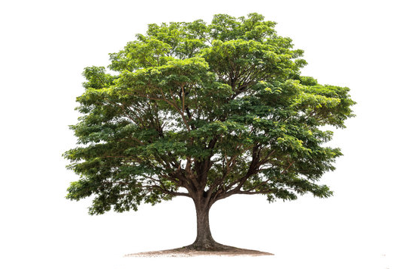

**Output:**

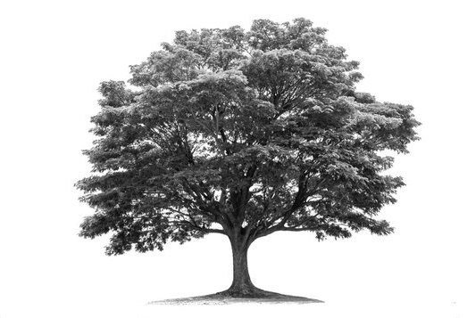

**Result:**

Gray scale conversion using python is successfully implemented.

1. **Perform basic Image Handling and processing operations on the image. Read an image in python and Convert an Image to Blur using Gaussian Blur.**

**Aim:**

To Perform Basic Operations to Read Image and Convert to Blur using Gaussian Blur.

**Code:**

import cv2

import numpy as np

kernel = np.ones((5,5),np.uint8)

print(kernel)

path = r"C:\Users\prith\Pictures\Saved Pictures\cvimage.jpg"

img = cv2.imread(path)

imgGray = cv2.cvtColor(img, cv2.COLOR_BGR2GRAY)

imgBlur = cv2.GaussianBlur(imgGray, (7,7), 0)

cv2.imshow('Blurred Image', imgBlur)

cv2.waitKey(0)

cv2.destroyAllWindows()

**Input:**



**Output:**

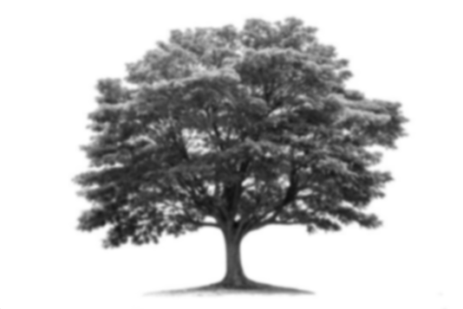

**Result:**

The python code to convert image to blur using gaussian blur.

1. **Perform basic Image Handling and processing operations on the image• Read an image in python and Convert an Image to show outline using Canny function**

**Aim:**

To Perform Basic Operations to Convert image to show outline Canny function in Python.

**Code:**

import cv2

import numpy as np

kernel = np.ones((5,5),np.uint8)

print(kernel)

path = "C:\\Users\\prith\\Pictures\\Saved Pictures\\cvimage.jpg"

img = cv2.imread(path)

imgGray = cv2.cvtColor(img,cv2.COLOR_BGR2GRAY)

imgBlur = cv2.GaussianBlur(imgGray,(7,7),0)

imgCanny = cv2.Canny(imgBlur,100,200)

cv2.imshow('Canny Edge Detection',imgCanny)

cv2.waitKey(0)

cv2.destroyAllWindows()

**Input:**



**Output:**

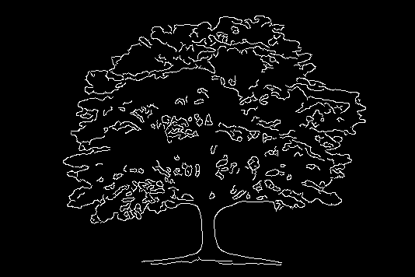

**Result:**

The python code to convert image to outline using canny function.

1. **Perform basic Image Handling and processing operations on the image• Read an image in python and Dilate an Image using Dilate function.**

**Aim:**

To Perform Basic Operations to Read Image and Dilate an Image using Python.

**Code:**

import cv2

import numpy as np

kernel = np.ones((5,5),np.uint8)

print(kernel)

path = "C:\\Users\\prith\\Documents\\CV\\cvimage.jpg"

img = cv2.imread(path)

imgGray = cv2.cvtColor(img,cv2.COLOR_BGR2GRAY)

imgBlur = cv2.GaussianBlur(imgGray,(7,7),0)

imgCanny = cv2.Canny(imgBlur,100,200)

imgDilation = cv2.dilate(imgCanny,kernel,iterations=10)

imgEroded = cv2.erode(imgDilation,kernel,iterations=2)

cv2.imshow('Eroded Image',imgEroded)

cv2.waitKey(0)

cv2.destroyAllWindows()

**Input:**



**Output:**

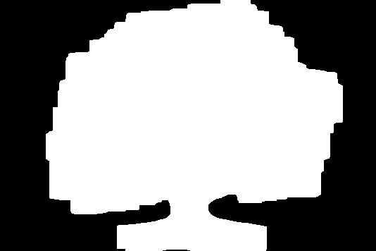

**Result:**

The python code to convert image to outline using dilate function.

1. **Perform basic Image Handling and processing operations on the image• Read an image in python and Erode an Image using erode function.**

**Aim:**

The Aim: of the experiment is to Read an image in python and Erode an Image using erode function.

**Code:**

import cv2

import numpy as np

path = "C:\\Users\\prith\\Documents\\CV\\cvimage.jpg"

img = cv2.imread(path)

imgGray = cv2.cvtColor(img, cv2.COLOR_BGR2GRAY)

kernel = np.ones((5, 5), np.uint8)

imgEroded = cv2.erode(imgGray, kernel, iterations=1)

cv2.imshow('Original Image', img)

cv2.imshow('Eroded Image', imgEroded)

cv2.waitKey(0)

cv2.destroyAllWindows()

**Input:**



**Output:**

**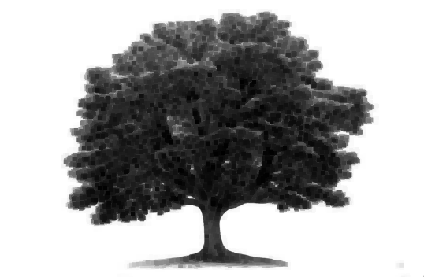  
  
Result:**

The python code to erode an image is successfully executed.

1. **Perform basic video processing operations on the captured video• Read captured video in python and display the video, in slow motion and in fast motion.**

**Aim:**

The Aim: of the experiment is to read captured video python and display the video, in slow motion and in fast motion.

**Code:**

import cv2

import numpy as np

video_path = r"C:\Users\prith\Documents\CV\cvVideo.mp4"

cap = cv2.VideoCapture(video_path)

if not cap.isOpened():

print("Error opening video file")

else:

while cap.isOpened():

ret, frame = cap.read()

if ret:

cv2.imshow('Frame', frame)

if cv2.waitKey(250) & 0xFF == ord('q'):

break

else:

break

cap.release()

cv2.destroyAllWindows()

**Input:**

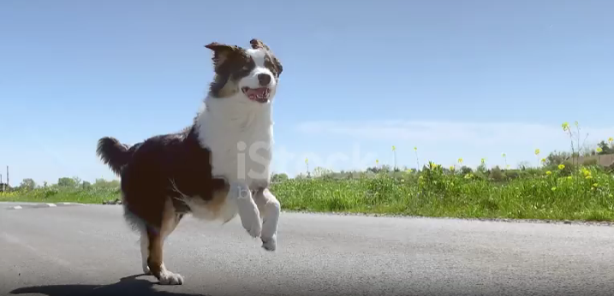

**Output:**

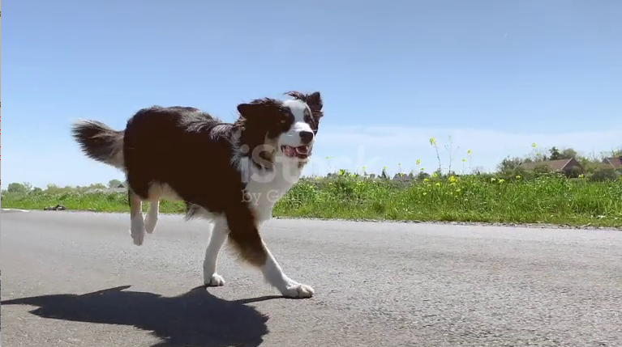

**Result:**

The captured video is read and displayed in slow motion.

1. **Capture video from web Camera and Display the video, in slow motion and in fast motion operations on the captured video.**

**Aim:**

The Aim: is to Capture video from web Camera and Display the video, in slow motion and in fast motion operations on the captured video.

**Code:**

import cv2

cap = cv2.VideoCapture(0)

if not cap.isOpened():

print("Error: Unable to access the webcam")

exit()

print("Press 's' for slow motion, 'f' for fast motion, 'n' for normal speed, and 'q' to quit.")

delay = 30

while True:

ret, frame = cap.read()

if not ret:

print("Error: Unable to read from webcam")

break

cv2.imshow("Webcam Video", frame)

key = cv2.waitKey(delay) & 0xFF

if key == ord('q'):

break

elif key == ord('s'):

delay = 100

elif key == ord('f'):

delay = 10

elif key == ord('n'):

delay = 30

cap.release()

cv2.destroyAllWindows()

**Result:**

The captured video is read and displayed successfully.

1. **Scaling an image to its Bigger and Smaller sizes.**

**Aim:**

The Aim: is resize the image from bigger to smaller size.

**Code:**import cv2

import numpy as np

img = cv2.imread("C:\\Users\\prith\\Documents\\CV\\cvimage.jpg", cv2.IMREAD_COLOR)

img = cv2.resize(img, (600, 600))

cv2.imshow('Resized Image', img)

cv2.waitKey(0)

cv2.destroyAllWindows()

**Input:**



**Output:**

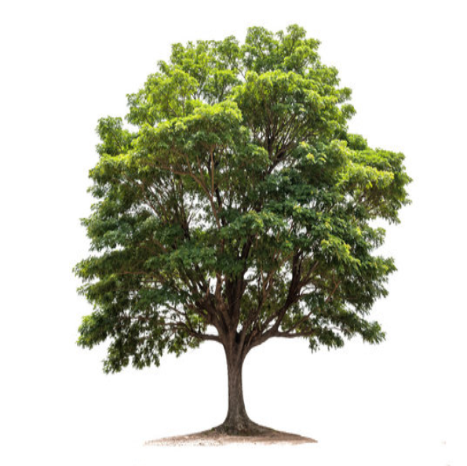

**Result:**

The python code to enlarge the picture has been successfully executed.

1. **Rotation 90 degree along the degree.**

**Aim:**

To rotate the input image in 90 degrees.

**Code:**

import cv2

path = r"C:\\Users\\prith\\Documents\\CV\\cvimage.jpg"

src = cv2.imread(path)

image = cv2.rotate(src, cv2.ROTATE_90_COUNTERCLOCKWISE)

cv2.imshow('Image', image)

cv2.waitKey(0)

cv2.destroyAllWindows()

**Input:**



**Output:**

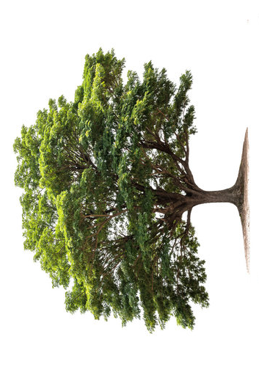

**Result:**

The input image has been rotated 90 degrees along the degree successfully.

1. **Rotation 180 degree along degree**

**Aim:**

To rotate the input image in 180 degrees.

**Code:**

import cv2

path = r"C:\\Users\\prith\\Documents\\CV\\cvimage.jpg"

src = cv2.imread(path)

image = cv2.rotate(src, cv2.ROTATE_180)

cv2.imshow('Image', image)

cv2.waitKey(0)

cv2.destroyAllWindows()

**Input:**



**Output:**

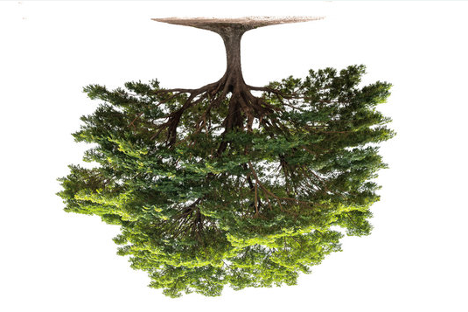

**Result:**

The input image has been rotated 180 degrees along the degree successfully.

1. **Rotation 270 along degree**

**Aim:**

To rotate the input image in 270 degrees.

**Code:**

import cv2

path = r"C:\\Users\\prith\\Documents\\CV\\cvimage.jpg"

src = cv2.imread(path)

image = cv2.rotate(src, cv2.ROTATE_90_CLOCKWISE)

cv2.imshow('Image', image)

cv2.waitKey(0)

cv2.destroyAllWindows()

**Input:**



**Output:**

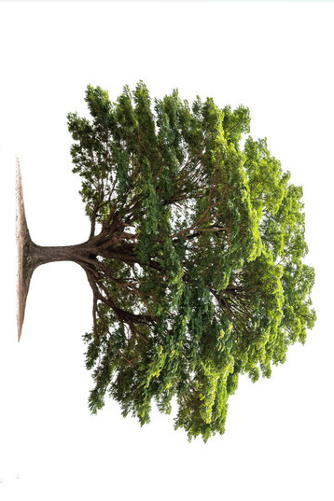

**Result:**

The input image has been rotated to 270 along the degree successfully.

1. **Perform Affine Transformation on the image.**

**Aim:**

To perform affine transformation on the input image.  
  
**Code:**

import cv2

import numpy as np

img = cv2.imread("C:\\Users\\prith\\Documents\\CV\\cvimage.jpg")

rows, cols, _ = img.shape

pts1 = np.float32([[50, 50], [200, 50], [50, 200]])

pts2 = np.float32([[10, 100], [200, 50], [100, 250]])

M = cv2.getAffineTransform(pts1, pts2)

dst = cv2.warpAffine(img, M, (cols, rows))

cv2.imshow('Affine Transformation', dst)

cv2.waitKey(0)

cv2.destroyAllWindows()

**Input:**



**Output:**

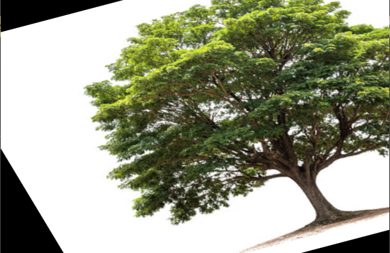

**Result:**

Python code to perform affine transformation on the input image has been executed successfully.

1. **Perform Perspective Transformation on the image.**

**Aim:**

To perform perspective transformation on the image.

**Code:**

import cv2

import numpy as np

img = cv2.imread("C:\\Users\\prith\\Documents\\CV\\cvimage.jpg")

rows, cols, ch = img.shape

pts1 = np.float32([[56, 65], [368, 52], [28, 387], [389, 390]])

pts2 = np.float32([[100, 50], [300, 0], [0, 300], [300, 300]])

M = cv2.getPerspectiveTransform(pts1, pts2)

dst = cv2.warpPerspective(img, M, (cols, rows))

cv2.imshow('Perspective Transformation', dst)

cv2.waitKey(0)

cv2.destroyAllWindows()

**Input:**



**Output:**

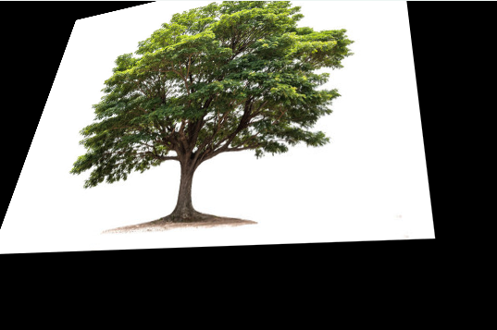

**Result:**

The python code to perform perspective transformation on an input image has been executed successfully.

1. **Perform Perspective Transformation on a video.**

**Aim:**

To perform perspective transformation on a video.

**Code:**

import cv2

import numpy as np

video_path = r"C:\\Users\\prith\\Documents\\CV\\cvVideo.mp4"

cap = cv2.VideoCapture(video_path)

if not cap.isOpened():

print("Error: Unable to open the video file")

exit()

ret, im_src = cap.read()

if not ret:

print("Error: Unable to read the video frame")

cap.release()

exit()

pts_src = np.array([[141, 131], [480, 159], [493, 630], [64, 601]])

pts_dst = np.array([[318, 256], [534, 372], [316, 670], [73, 473]])

im_dst = np.zeros_like(im_src)

h, status = cv2.findHomography(pts_src, pts_dst)

im_out = cv2.warpPerspective(im_src, h, (im_src.shape[1], im_src.shape[0]))

cv2.imshow("Source Image", im_src)

cv2.imshow("Destination Image", im_dst)

cv2.imshow("Warped Source Image", im_out)

cv2.waitKey(0)

cap.release()

cv2.destroyAllWindows()

**Input:**



**Output:**

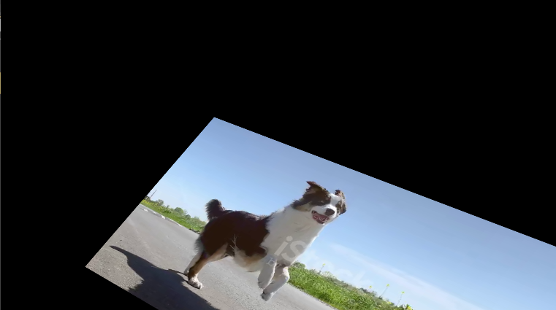

**Result:**

The python code to perform perspective transformation on an input video has been executed successfully.

1. **Perform transformation using homography matrix.**

**Aim:**

To perform transformation using homography matrix.

**Code:**

import cv2

import numpy as np

im_src = cv2.imread("C:\\Users\\prith\\Documents\\CV\\cvimage.jpg")

pts_src = np.array([[141, 131], [480, 159], [493, 630], [64, 601]])

im_dst = cv2.imread("C:\\Users\\prith\\Documents\\CV\\cvimage.jpg")

pts_dst = np.array([[318, 256], [534, 372], [316, 670], [73, 473]])

h, status = cv2.findHomography(pts_src, pts_dst)

if im_dst is not None:

im_out = cv2.warpPerspective(im_src, h, (im_dst.shape[1], im_dst.shape[0]))

cv2.imshow('Source Image', im_src)

cv2.imshow('Destination Image', im_dst)

cv2.imshow('Warped Image', im_out)

cv2.waitKey(0)

cv2.destroyAllWindows()

else:

print("Error: Could not load destination image.")

**Input:**



**Output:**

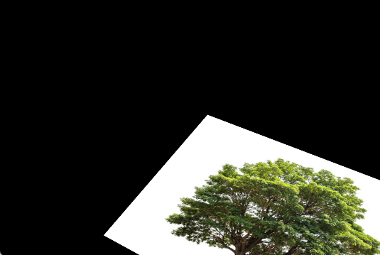

**Result:**

The python code to perform transformation using homography matrix has been executed successfully.

1. **Perform transformation using Direct Linear Transformation**

**Aim:**

To perform transformation using direct linear transformation with python code.

**Code:**

import cv2

import numpy as np

img1 = cv2.imread("C:\\Users\\prith\\Documents\\CV\\cvimage.jpg")

img2 = cv2.imread("C:\\Users\\prith\\Documents\\CV\\cvimage.jpg")

pts1 = np.array([[50, 50], [200, 50], [50, 200], [200, 200]])

pts2 = np.array([[100, 100], [300, 100], [100, 300], [300, 300]])

H, _ = cv2.findHomography(pts1, pts2)

dst = cv2.warpPerspective(img1, H, (img2.shape[1], img2.shape[0]))

cv2.imshow("Image 1", img1)

cv2.imshow("Image 2", img2)

cv2.imshow("Transformed Image", dst)

cv2.waitKey(0)

cv2.destroyAllWindows()

**Input:**



**Output:**

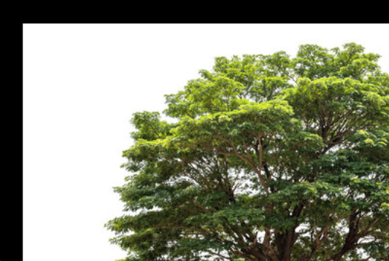

**Result:**

The python code to perform transformation using direct linear transformation on an input image has been executed successfully.

1. **Perform edge detection using Canny Method.**

**Aim:**

To perform edge detection using Canny Method on an image using python.

**Code:**

import cv2

import numpy as np

img = cv2.imread(r"C:\Users\prith\Documents\CV\cvimage.jpg")

cv2.imshow('Original', img)

cv2.waitKey(0)

img_gray = cv2.cvtColor(img, cv2.COLOR_BGR2GRAY)

img_blur = cv2.GaussianBlur(img_gray, (3,3), 0)

sobelx = cv2.Sobel(src=img_blur, ddepth=cv2.CV_64F, dx=1, dy=0, ksize=5)

sobelx = cv2.convertScaleAbs(sobelx)

cv2.imshow('Sobel X', sobelx)

cv2.waitKey(0)

cv2.destroyAllWindows()

**Input:**



**Output:**

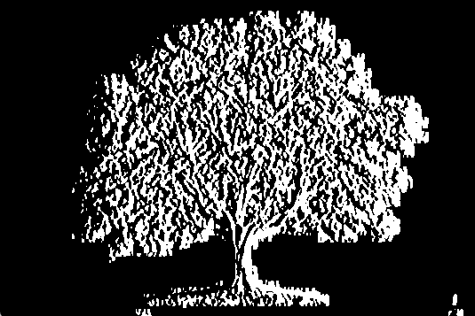

**Result:**

The python code to perform edge detection using Canny Method on an image has been executed successfully.

1. **Perform edge detection using Sobel Matrix along x-axis**

**Aim:**

To perform edge detection using Sobel Matrix along x-axis using python.

**Code:**

import cv2

import numpy as np

img = cv2.imread(r"C:\Users\prith\Documents\CV\cvimage.jpg")

cv2.imshow('Original', img)

cv2.waitKey(0)

img_gray = cv2.cvtColor(img, cv2.COLOR_BGR2GRAY)

img_blur = cv2.GaussianBlur(img_gray, (3,3), 0)

sobelx = cv2.Sobel(src=img_blur, ddepth=cv2.CV_64F, dx=1, dy=0, ksize=5)

sobelx = cv2.convertScaleAbs(sobelx)

cv2.imshow('Sobel X', sobelx)

cv2.waitKey(0)

cv2.destroyAllWindows()

**Input:**



**Output:**

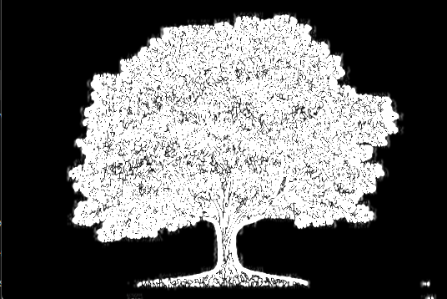

**Result:**

The python code to perform edge detection using Sobel Matrix along x-axis has been executed successfully.

1. **Perform edge detection using Sobel Matrix along y-axis**

**Aim:**

To perform edge detection using Sobel Matrix along y-axis on an image using python.

**Code:**

import cv2

img = cv2.imread("C:\\Users\\prith\\Documents\\CV\\cvimage.jpg")

cv2.imshow('Original', img)

cv2.waitKey(0)

img_gray = cv2.cvtColor(img, cv2.COLOR_BGR2GRAY)

img_blur = cv2.GaussianBlur(img_gray, (3,3), 0)

sobely = cv2.Sobel(src=img_blur, ddepth=cv2.CV_64F, dx=0, dy=1, ksize=5)

sobely = cv2.convertScaleAbs(sobely)

cv2.imshow('Sobel Y', sobely)

cv2.waitKey(0)

cv2.destroyAllWindows()

**Input:**



**Output:**

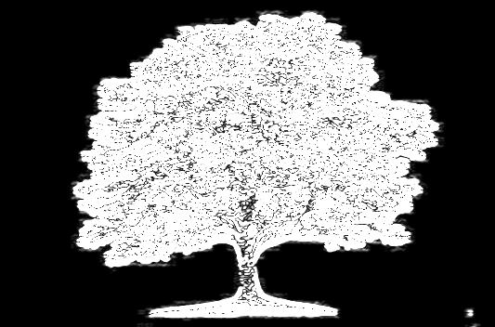

**Result:**

The python code to perform edge detection using Sobel Matrix along y-axis on an image has been executed successfully.

1. **Perform edge detection using Sobel Matrix along xy-axis**

**Aim:**

To perform edge detection using Sobel Matrix along xy-axis using python.

**Code:**

import cv2

import numpy as np

img = cv2.imread(r"C:\Users\prith\Documents\CV\cvimage.jpg")

gray = cv2.cvtColor(img, cv2.COLOR_BGR2GRAY)

kernel = np.array([[0,1,0], [1,-8,1], [0,1,0]])

sharpened = cv2.filter2D(gray, -1, kernel)

cv2.imshow('Original', gray)

cv2.imshow('Sharpened', sharpened)

cv2.waitKey(0)

cv2.destroyAllWindows()

**Input:**



**Output:**

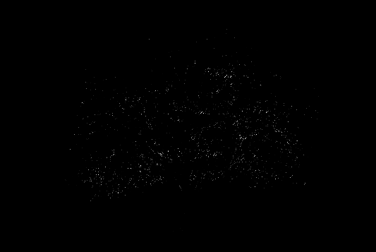

**Result:**

The python code to perform edge detection using Sobel Matrix along xy-axis on an image has been executed successfully.

1. **Perform sharpening of image using Laplacian Mask with negative centre coefficient.**

**Aim:**

To perform sharpening of image using Laplacian Mask with negative centre coefficient using python.

**Code:**

import cv2

import numpy as np

img=cv2.imread("C:\\Users\\prith\\Documents\\CV\\cvimage.jpg")

gray=cv2.cvtColor(img,cv2.COLOR_BGR2GRAY)

kernel=np.array([[0,1,0],[1,-8,1],[0,1,0]])

sharpened=cv2.filter2D(gray,-1,kernel)

cv2.imshow('Original Grayscale',gray)

cv2.imshow('Sharpened Image',sharpened)

cv2.waitKey(0)

cv2.destroyAllWindows()

**Input:**



**Output:**

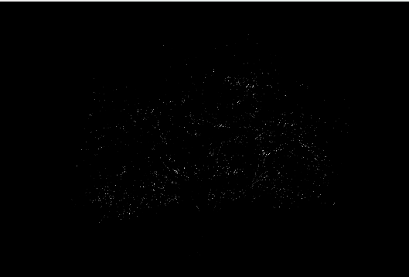

**Result:**

The python code to perform sharpening of image using Laplacian Mask with negative centre coefficient has been executed successfully.

1. **Perform sharpening of image using Laplacian mask implemented with an extension of diagonal neighbours.**

**Aim:**

To perform sharpening of image using Laplacian mask implemented with an extension of diagonal neighbours using python.

**Code:**

import cv2

import numpy as np

img = cv2.imread(r"C:\\Users\\prith\\Documents\\CV\\cvimage.jpg")

gray = cv2.cvtColor(img, cv2.COLOR_BGR2GRAY)

kernel = np.array([[0,1,0], [1,-4,1], [0,1,0]])

sharpened = cv2.filter2D(gray, -1, kernel)

cv2.imshow('Original', gray)

cv2.imshow('Sharpened', sharpened)

cv2.waitKey(0)

cv2.destroyAllWindows()

**Input:**



**Output:**

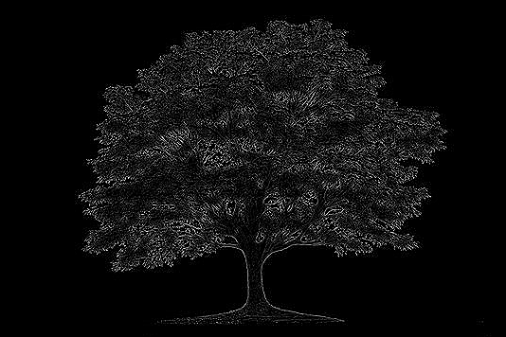

**Result:**

The python code to perform sharpening of image using Laplacian mask implemented with an extension of diagonal neighbours has been executed successfully.

1. **Perform Sharpening of Image using Laplacian mask with positive centre coefficient.**

**Aim:**

To perform sharpening of image using Laplacian mask with positive centre coefficient using python.

**Code:**

import cv2

import numpy as np

img = cv2.imread(r"C:\Users\prith\Documents\CV\cvimage.jpg")

gray = cv2.cvtColor(img, cv2.COLOR_BGR2GRAY)

kernel = np.array([[0,1,0], [1,-8,1], [0,1,0]])

sharpened = cv2.filter2D(gray, -1, kernel)

cv2.imshow('Original', gray)

cv2.imshow('Sharpened', sharpened)

cv2.waitKey(0)

cv2.destroyAllWindows()

**Input:**



**Output:**

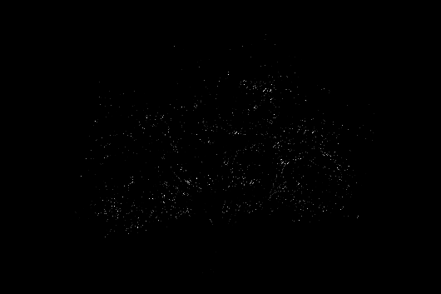

**Result:**

The python code to perform sharpening of image using Laplacian mask with positive centre coefficient has been executed successfully.

1. **Perform Sharpening of Image using unsharp masking.**

**Aim:**

To perform sharpening of image using unsharp masking python.

**Code:**

import cv2

import numpy as np

img = cv2.imread("C:\\Users\\prith\\Documents\\CV\\cvimage.jpg")

gray = cv2.cvtColor(img, cv2.COLOR_BGR2GRAY)

laplacian_kernel = np.array([[0, 1, 0], [1, -4, 1], [0, 1, 0]])

laplacian = cv2.filter2D(gray, -1, laplacian_kernel)

sharpened = cv2.add(gray, laplacian)

cv2.imshow('Original Grayscale', gray)

cv2.imshow('Sharpened Image', sharpened)

cv2.waitKey(0)

cv2.destroyAllWindows()

**Input:**



**Output:**

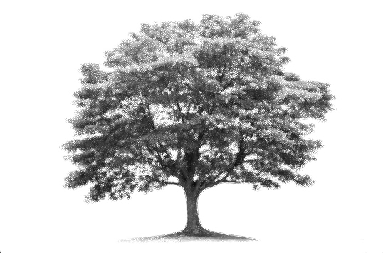

**Result:**

The python code to perform sharpening of image using unsharp masking has been executed successfully.

1. **Perform Sharpening of Image using High-Boost Masks.**

**Aim:**

To perform Sharpening of Image using High-Boost Masks.

**Code:**

**Input:**



**Output:**

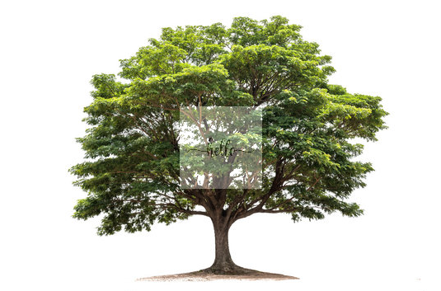

**Result:**

The python code to perform Sharpening of Image using High-Boost Masks has been executed successfully.

1. **Perform Sharpening of Image using Gradient masking**

**Aim:**

To perform sharpening of image using gradient sharpening using python.

**Code:**

import cv2

import numpy as np

image = cv2.imread(r"C:\\Users\\prith\\Documents\\CV\\cvimage.jpg", cv2.IMREAD_COLOR)

if image is None:

print("Error: Could not load the image. Check the file path.")

exit()

gray_image = cv2.cvtColor(image, cv2.COLOR_BGR2GRAY)

sobel_x = cv2.Sobel(gray_image, cv2.CV_64F, 1, 0, ksize=3)

sobel_y = cv2.Sobel(gray_image, cv2.CV_64F, 0, 1, ksize=3)

gradient_magnitude = cv2.magnitude(sobel_x, sobel_y)

gradient_magnitude = cv2.convertScaleAbs(gradient_magnitude)

alpha = 1

beta = 0.5

sharpened_image = cv2.addWeighted(gray_image, alpha, gradient_magnitude, beta, 0)

cv2.imshow("Original Image", gray_image)

cv2.imshow("Gradient Magnitude (Mask)", gradient_magnitude)

cv2.imshow("Sharpened Image", sharpened_image)

cv2.waitKey(0)

cv2.destroyAllWindows()

**Input:**



**Output:**

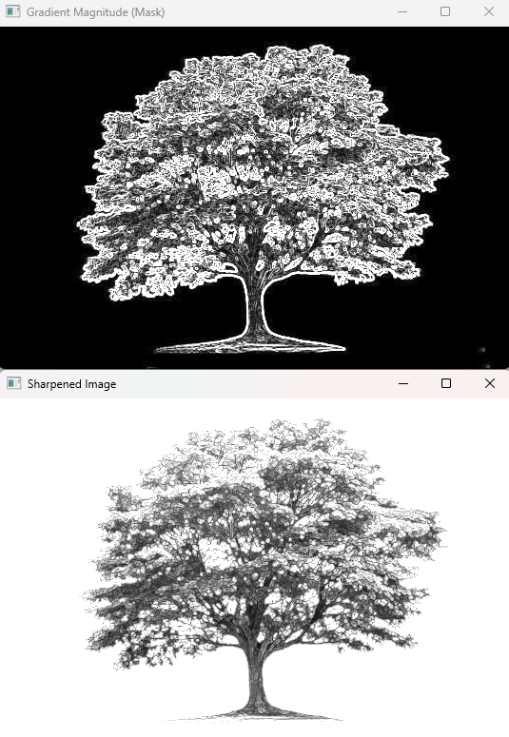

**Result:**

The python code to perform Sharpening of Image using gradient masking has been executed successfully.

1. **Insert water marking to the image using OpenCV.**

**Aim:**

To perform watermarking to the image using opencv.

**Code:**

import cv2

img = cv2.imread(r"C:\Users\prith\Documents\CV\cvimage.jpg")

wm = cv2.imread(r"C:\Users\prith\Documents\CV\cvimage.jpg")

h_wm, w_wm = wm.shape[:2]

h_img, w_img = img.shape[:2]

center_x = int(w_img/2)

center_y = int(h_img/2)

top_y = center_y - int(h_wm/2)

left_x = center_x - int(w_wm/2)

bottom_y = top_y + h_wm

right_x = left_x + w_wm

roi = img[top_y:bottom_y, left_x:right_x]

result = cv2.addWeighted(roi, 1, wm, 0.3, 0)

img[top_y:bottom_y, left_x:right_x] = result

cv2.imshow("Watermarked Image", img)

cv2.waitKey(0)

cv2.destroyAllWindows()

**Input:**



**Output:**

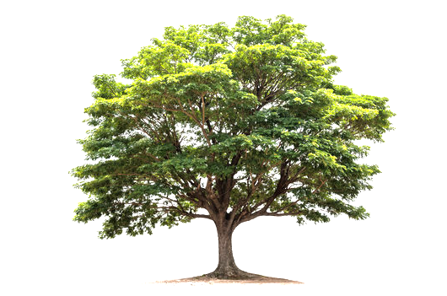

**Result:**

The python code to perform watermarking an image has been executed successfully.

1. **Do Cropping, Copying and pasting image inside another image using OpenCV**

**Aim:**

To perform cropping, copying and pasting an image inside another image using opencv.

**Code:**

import cv2

import numpy as np

image = cv2.imread(r"C:\Users\prith\Documents\CV\cvimage.jpg")

img2 = cv2.imread(r"C:\Users\prith\Documents\CV\cvimage.jpg")

print(image.shape)

cv2.imshow("Original Image", image)

imageCopy = image.copy()

cv2.circle(imageCopy, (100, 100), 30, (255, 0, 0), -1)

cv2.imshow("Original Image", image)

cv2.imshow("Image with Circle", imageCopy)

cropped_image = image[80:280, 150:330]

cv2.imshow("Cropped Image", cropped_image)

cv2.imwrite("Cropped Image.jpg", cropped_image)

dst = cv2.addWeighted(image, 0.5, img2, 0.7, 0)

img_arr = np.hstack((image, img2))

cv2.imshow("Image Pair", img_arr)

cv2.imshow("Weighted Image", dst)

cv2.waitKey(0)

cv2.destroyAllWindows()

**Input:**



**Output:**

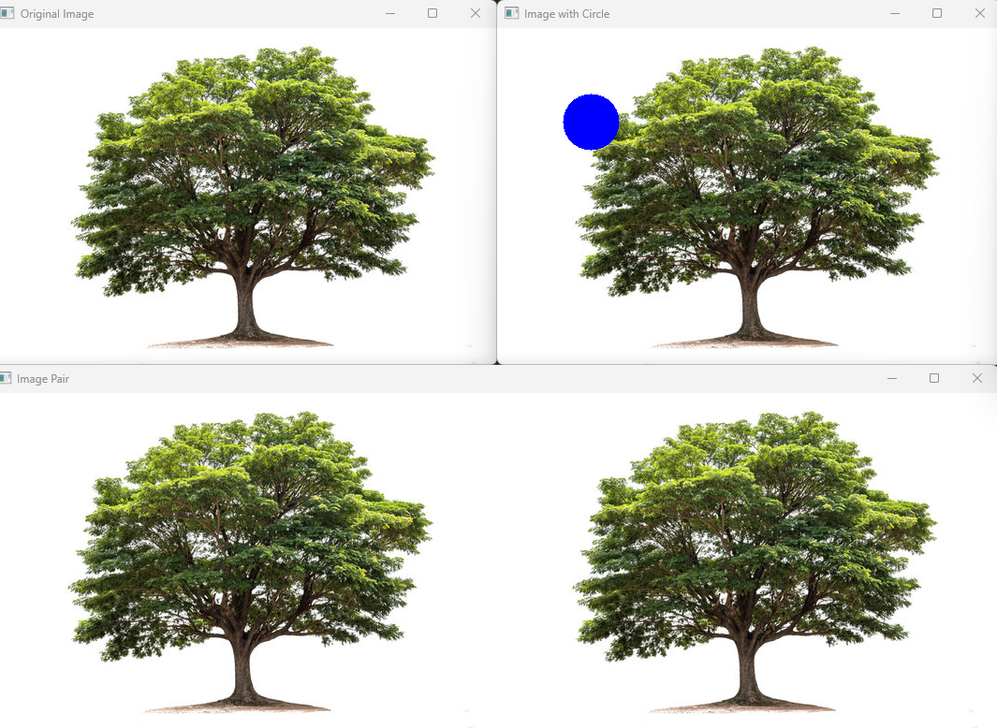

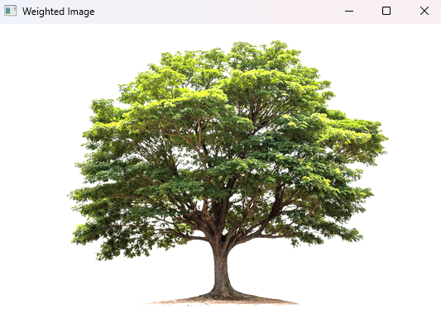

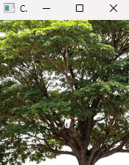

**Result:**

The python code to perform cropping, copying and pasting an image inside another image using opencv has been executed successfully.

1. **Find the boundary of the image using Convolution kernel for the given image**

**Aim:**

To find the boundary of the image using a convolution kernel for the given image.

**Code:**

import cv2

import numpy as np

import matplotlib.pyplot as plt

image = cv2.imread(r"C:\Users\prith\Documents\CV\cvimage.jpg", cv2.IMREAD_GRAYSCALE)

sobel_x = np.array([[-1, 0, 1],

[-2, 0, 2],

[-1, 0, 1]])

sobel_y = np.array([[-1, -2, -1],

[ 0, 0, 0],

[ 1, 2, 1]])

edges_x = cv2.filter2D(image, -1, sobel_x)

edges_y = cv2.filter2D(image, -1, sobel_y)

edges = cv2.magnitude(edges_x.astype(np.float32), edges_y.astype(np.float32))

edges = cv2.normalize(edges, None, 0, 255, cv2.NORM_MINMAX).astype(np.uint8)

plt.figure(figsize=(10, 5))

plt.subplot(1, 3, 1)

plt.title('Original Image')

plt.imshow(image, cmap='gray')

plt.subplot(1, 3, 2)

plt.title('Edges X')

plt.imshow(edges_x, cmap='gray')

plt.subplot(1, 3, 3)

plt.title('Edges Y')

plt.imshow(edges_y, cmap='gray')

plt.figure()

plt.title('Combined Edges')

plt.imshow(edges, cmap='gray')

plt.show()

**Input:**



**Output:**

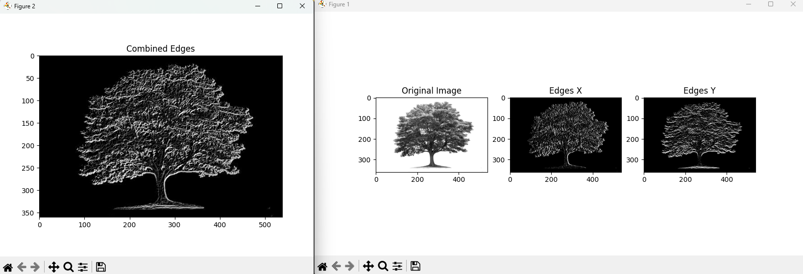

**Result:**

The python code to find the boundary of the image using a convolution kernel for the given image has been executed successfully.

1. **Morphological operations based on OpenCV using Erosion technique**

**Aim:**

To perform morphological operations on opencv using erosion technique.

**Code:**

import cv2

import numpy as np

import matplotlib.pyplot as plt

image = cv2.imread(r"C:\Users\prith\Documents\CV\cvimage.jpg", cv2.IMREAD_GRAYSCALE)

kernel = np.ones((5, 5), np.uint8)

eroded_image = cv2.erode(image, kernel, iterations=1)

plt.figure(figsize=(10, 5))

plt.subplot(1, 2, 1)

plt.title('Original Image')

plt.imshow(image, cmap='gray')

plt.subplot(1, 2, 2)

plt.title('Eroded Image')

plt.imshow(eroded_image, cmap='gray')

plt.show()

**Input:**



**Output:**

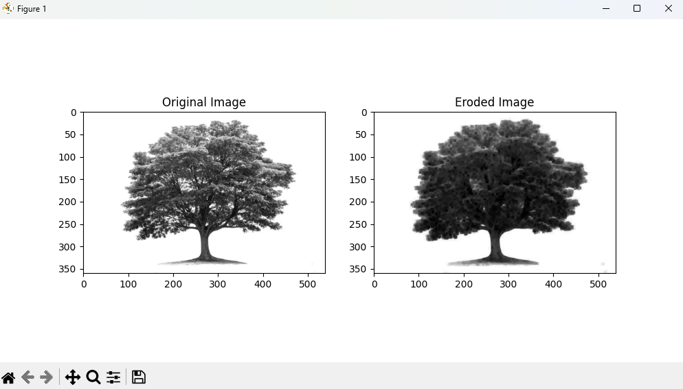

**Result:**

The python code to perform morphological operations on opencv using erosion technique has been executed successfully.

1. **Morphological operations based on OpenCV using Dilation technique**

**Aim:**

To perform morphological operations based on opencv using dilation technique.

**Code:**

import cv2

import numpy as np

import matplotlib.pyplot as plt

image = cv2.imread(r"C:\Users\prith\Documents\CV\cvimage.jpg", cv2.IMREAD_GRAYSCALE)

kernel = np.ones((5, 5), np.uint8)

dilated_image = cv2.dilate(image, kernel, iterations=1)

plt.figure(figsize=(10, 5))

plt.subplot(1, 2, 1)

plt.title('Original Image')

plt.imshow(image, cmap='gray')

plt.subplot(1, 2, 2)

plt.title('Dilated Image')

plt.imshow(dilated_image, cmap='gray')

plt.show()

**Input:**



**Output:**

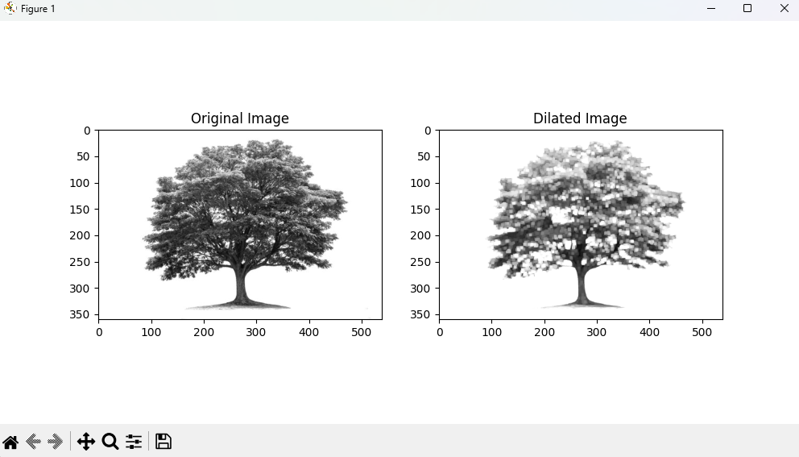

**Result:**

The python code to perform morphological operations based on opencv using dilation technique has been executed successfully.

1. **Morphological operations based on OpenCV using Opening technique.**

**Aim:**

To perform morphological operations based on open cv using opening technique.

**Code:**

import cv2

import numpy as np

img = cv2.imread(r"C:\Users\prith\Documents\CV\cvimage.jpg", cv2.IMREAD_GRAYSCALE)

kernel = np.ones((5, 5), np.uint8)

opening = cv2.morphologyEx(img, cv2.MORPH_OPEN, kernel)

cv2.imshow("Original", img)

cv2.imshow("Opening", opening)

cv2.waitKey(0)

cv2.destroyAllWindows()

**Input:**



**Output:**

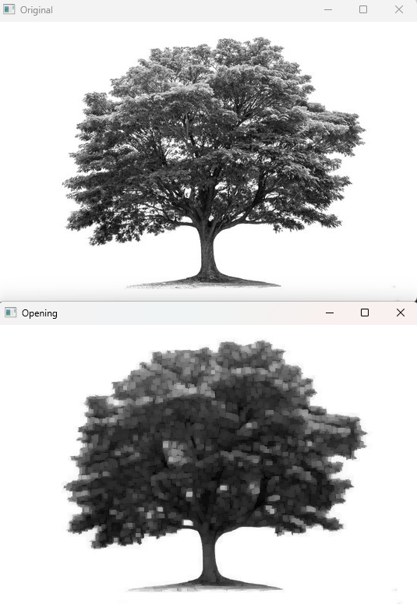

**Result:**

The python code to perform morphological operations based on open cv using opening technique has been executed successfully.

1. **Morphological operations based on OpenCV using Closing technique.**

**Aim:**

To perform operations based on opencv using closure technique.

**Code:**

import cv2

import numpy as np

img = cv2.imread(r"C:\Users\ADMIN\Pictures\images (1).jfif", cv2.IMREAD_GRAYSCALE)

kernel = np.ones((5,5), np.uint8)

closing = cv2.morphologyEx(img, cv2.MORPH_CLOSE, kernel)

cv2.imshow("Original", img)

cv2.imshow("Closing", closing)

cv2.waitKey(0)

cv2.destroyAllWindows()

**Input:**



**Output:**

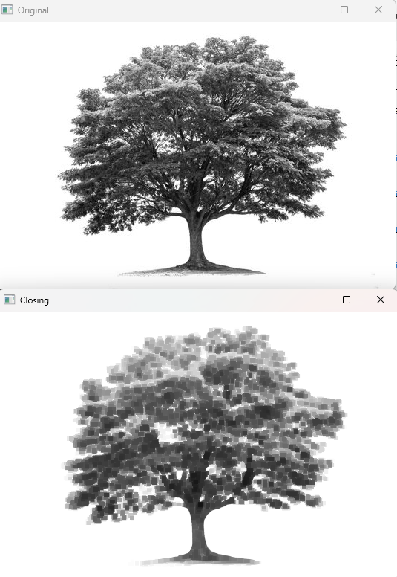

**Result:**

The python code to perform operations based on opencv using closure technique has been executed successfully.

1. **Morphological operations based on OpenCV using Morphological Gradient technique**

**Aim:**

To perform morphological operations based on opencv using morphological gradient technique.

**Code:**

import cv2

import numpy as np

img = cv2.imread(r"C:\Users\prith\Documents\CV\cvimage.jpg", cv2.IMREAD_GRAYSCALE)

kernel = np.ones((5, 5), np.uint8)

grad = cv2.morphologyEx(img, cv2.MORPH_GRADIENT, kernel)

cv2.imshow("Original", img)

cv2.imshow("Gradient", grad)

cv2.waitKey(0)

cv2.destroyAllWindows()

**Input:**



**Output:**

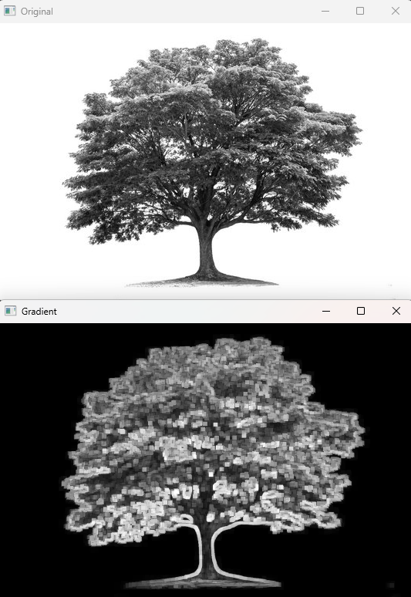

**Result:**

The python code to perform morphological operations based on opencv using morphological gradient technique has been executed successfully.

1. **Morphological operations based on OpenCV using Top hat technique.**

**Aim:**

To perform morphological operations based on open cv using top hat technique.

**Code:**

import cv2

import numpy as np

import matplotlib.pyplot as plt

image = cv2.imread(r"C:\Users\prith\Documents\CV\cvimage.jpg", cv2.IMREAD_GRAYSCALE)

kernel = np.ones((15, 15), np.uint8)

top_hat = cv2.morphologyEx(image, cv2.MORPH_TOPHAT, kernel)

plt.figure(figsize=(10, 5))

plt.subplot(1, 2, 1)

plt.title('Original Image')

plt.imshow(image, cmap='gray')

plt.subplot(1, 2, 2)

plt.title('Top Hat Image')

plt.imshow(top_hat, cmap='gray')

plt.show()

**Input:**



**Output:**

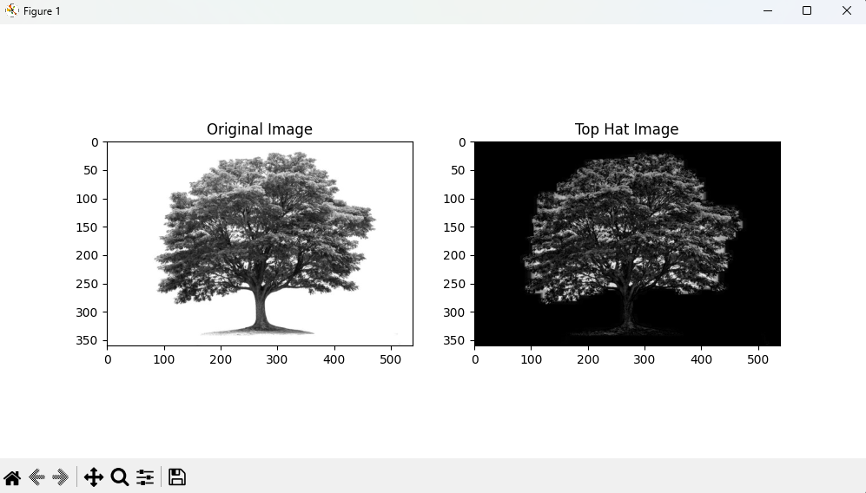

**Result:**

The python code to perform morphological operations based on open cv using top hat technique has been executed successfully.

1. **Morphological operations based on OpenCV using Black hat technique.**

**Aim:**

To perform morphological operations based on opencv using black hat technique.

**Code:**

import cv2

import numpy as np

import matplotlib.pyplot as plt

image = cv2.imread(r"C:\Users\prith\Documents\CV\cvimage.jpg", cv2.IMREAD_GRAYSCALE)

kernel = np.ones((15, 15), np.uint8)

black_hat = cv2.morphologyEx(image, cv2.MORPH_BLACKHAT, kernel)

plt.figure(figsize=(10, 5))

plt.subplot(1, 2, 1)

plt.title('Original Image')

plt.imshow(image, cmap='gray')

plt.subplot(1, 2, 2)

plt.title('Black Hat Image')

plt.imshow(black_hat, cmap='gray')

plt.show()

**Input:**



**Output:**

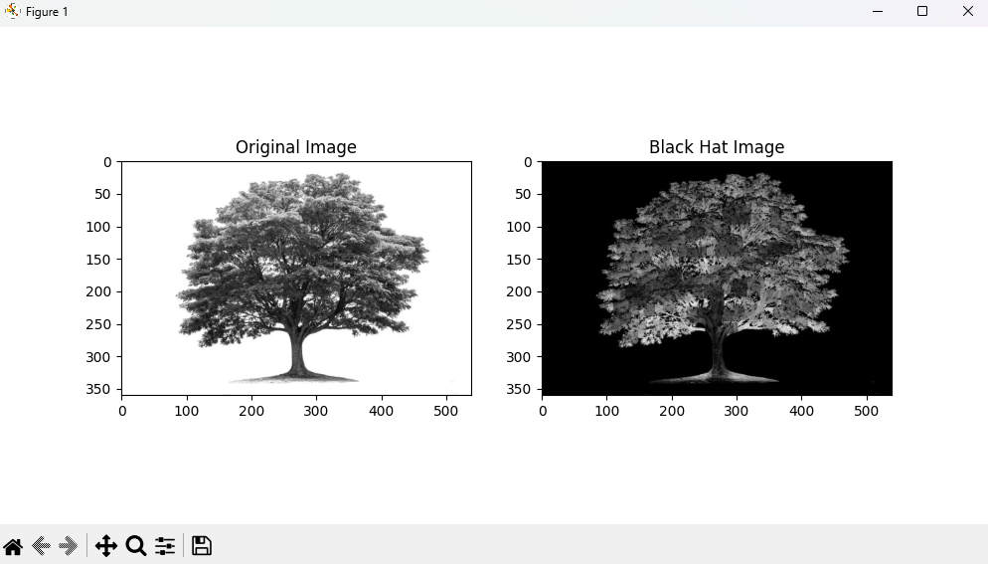

**Result:**

The python code to perform morphological operations based on opencv using black hat technique has been executed successfully.

1. **Recognise LEAF from the given image by general Object recognition using OpenCV.**

**Aim:**

To recognize leaf from the given image by general object recognition using opencv.

**Code:**

import cv2

import numpy as np

import matplotlib.pyplot as plt

image = cv2.imread(r"C:\Users\prith\Documents\CV\cvimage.jpg")

gray = cv2.cvtColor(image, cv2.COLOR_BGR2GRAY)

blurred = cv2.GaussianBlur(gray, (5, 5), 0)

_, thresh = cv2.threshold(blurred, 60, 255, cv2.THRESH_BINARY_INV)

contours, _ = cv2.findContours(thresh, cv2.RETR_EXTERNAL, cv2.CHAIN_APPROX_SIMPLE)

leaf_contour = max(contours, key=cv2.contourArea)

cv2.drawContours(image, [leaf_contour], -1, (0, 255, 0), 3)

plt.figure(figsize=(10, 5))

plt.subplot(1, 2, 1)

plt.title('Original Image')

plt.imshow(cv2.cvtColor(image, cv2.COLOR_BGR2RGB))

plt.subplot(1, 2, 2)

plt.title('Threshold Image')

plt.imshow(thresh, cmap='gray')

plt.show()

**Input:**



**Output:**

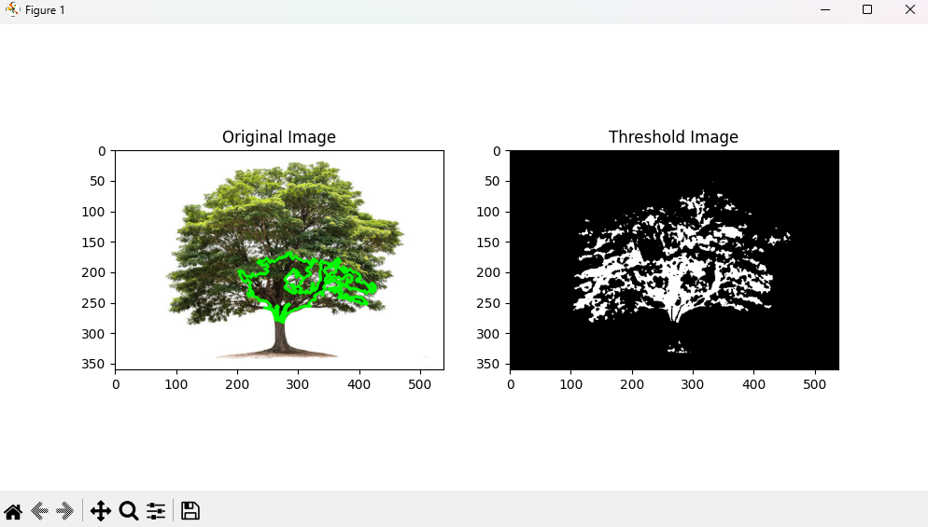

**Result:**

The python code to recognize leaf from the given image by general object recognition using opencv has been executed successfully.

1. **Using Opencv play Video in Reverse mode**

**Aim:**

To play video in reverse using opencv.

**Code:**

import cv2

video_path = r"C:\Users\prith\Documents\CV\cvVideo.mp4"

cap = cv2.VideoCapture(video_path)

if not cap.isOpened():

print("Error: Could not open the video file. Check the file path.")

exit()

total_frames = int(cap.get(cv2.CAP_PROP_FRAME_COUNT))

current_frame = total_frames - 1

while current_frame >= 0:

cap.set(cv2.CAP_PROP_POS_FRAMES, current_frame)

ret, frame = cap.read()

if not ret:

print(f"Error: Unable to read frame {current_frame}.")

break

cv2.imshow('Video in Reverse', frame)

if cv2.waitKey(25) & 0xFF == ord('q'):

break

current_frame -= 1

cap.release()

cv2.destroyAllWindows()

**Output:**

**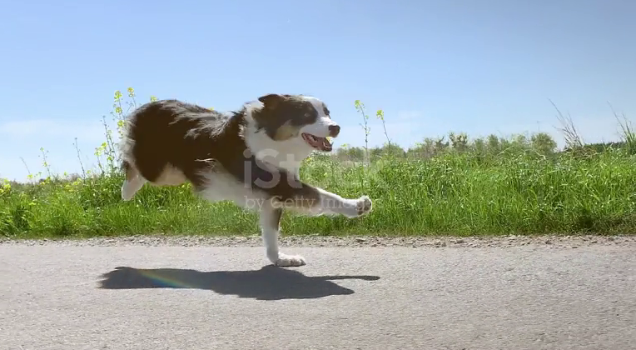  
  
Result:**

The python code to play video in reverse using opencv has been executed successfully.

1. **Face Detection using Opencv**

**Aim:**

To recognize face using opencv.

**Code:**

import cv2

image_path = r"C:\Users\prith\Documents\CV\cvimage3.jpg"

img = cv2.imread(image_path)

if img is None:

print("Error: Could not load the image. Check the file path.")

exit()

gray = cv2.cvtColor(img, cv2.COLOR_BGR2GRAY)

haar_cascade_path = cv2.data.haarcascades + "haarcascade_frontalface_default.xml"

face_cascade = cv2.CascadeClassifier(haar_cascade_path)

if face_cascade.empty():

print("Error: Could not load the Haar Cascade file.")

exit()

faces = face_cascade.detectMultiScale(gray, scaleFactor=1.1, minNeighbors=5)

for (x, y, w, h) in faces:

cv2.rectangle(img, (x, y), (x + w, y + h), (0, 255, 0), 2)

cv2.imshow('Faces Detected', img)

cv2.waitKey(0)

cv2.destroyAllWindows()

**Input:**

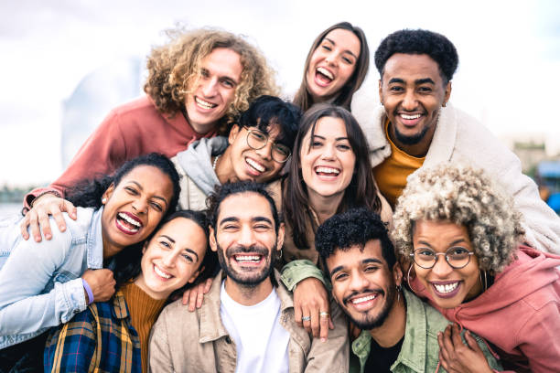

**Output:**

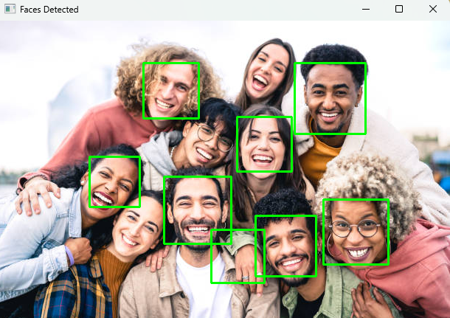

**Result:**

The python code to recognize face using opencv has been executed successfully.

1. **Draw Rectangular shape and extract objects**

**Aim:**

To draw a rectangular shape in the image to extract objects

**Code:**

import cv2

import numpy as np

import matplotlib.pyplot as plt

image_path = r"C:\Users\prith\Documents\CV\cvimage4.jpg"

image = cv2.imread(image_path)

if image is None:

print("Error: Could not load the image. Check the file path.")

exit()

gray = cv2.cvtColor(image, cv2.COLOR_BGR2GRAY)

blurred = cv2.GaussianBlur(gray, (5, 5), 0)

_, thresh = cv2.threshold(blurred, 60, 255, cv2.THRESH_BINARY_INV)

contours, _ = cv2.findContours(thresh, cv2.RETR_EXTERNAL, cv2.CHAIN_APPROX_SIMPLE)

output_image = image.copy()

for contour in contours:

x, y, w, h = cv2.boundingRect(contour)

cv2.rectangle(output_image, (x, y), (x + w, y + h), (0, 255, 0), 2)

extracted_object = image[y:y + h, x:x + w]

cv2.imshow('Extracted Object', extracted_object)

cv2.waitKey(0)

cv2.imshow('Output Image', output_image)

cv2.waitKey(0)

cv2.destroyAllWindows()

**Input:**



**Output:**

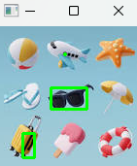

**Result:**

The python code to draw a rectangular shape in the image to extract objects has been executed successfully.